SOFTWARE REQUIREMENTS SPECIFICATION

# JOB PORTAL SYSTEM

**Prepared by :-**

NAVEEN KUMAR.S

SABARI.T

PRADEEEP.S

## 1. Introduction

1.1Purpose

The main objective of this document is to illustrate the requirements of the project job portal system. The document gives the detailed description of the both functional and non-functional requirements proposed by the job seeker. The purpose of this project is to provide a details of job vacancies Enable job seekers to search for job listings, submit applications and manage their profiles. Facilitate employer to post their job.

vacancies, review applications and manage their hiring process. Provide a user-friendly interface for seamless interaction between job seekers and employers. This project describes the hardware and software interface requirements using ER diagrams and UML diagrams.

1. Document Conventions
2. Entire word document should be justified

Convention for Main title

*Font face: Times New Roman

* Font style: Bold

*Font style:14

1. Convention for Sub title

*Font face: Times New Roman

*Font style: Bold

*Font Size: 12

3.Convention for body

*Font face: Times New Roman

*Font Size: 12

1.3 Scope of Development Project

Job portal System is basically updating the manual job vacancies into an internet-based application so that the users can know the details of their jobs, availability of vacancies and maximum limit for registering.

The project is specifically designed for the use of job seekers. It have job search functionality with advanced filters. job portal system reporting the analytics.

The project can be easily implemented under various situations. We can add new features as and when we require, making reusability possible as there is flexibility in all the modules.

The language used for developing the project is Java as it is quite advantageous than other languages in terms of performance, tools available, cross platform compatibility, libraries, cost (freely available), and development process.

1. Definitions, Acronyms and Abbreviations

JAVA -> platform independence

SQL-> Structured query Language

ER-> Entity Relationship

UML -> Unified Modeling Language

IDE-> Integrated Development

Reference:

websites

[https://careers.mrcooper.com/](https://careers.mrcooper.com/%20)

[https://in.indeed.com/](%20https://in.indeed.com/%20)

<https://www.naukri.com/>

<https://in.linkedin.com/>

## 2. Overall Descriptions

1. Product Perspective

Use Case Diagram of job portal :

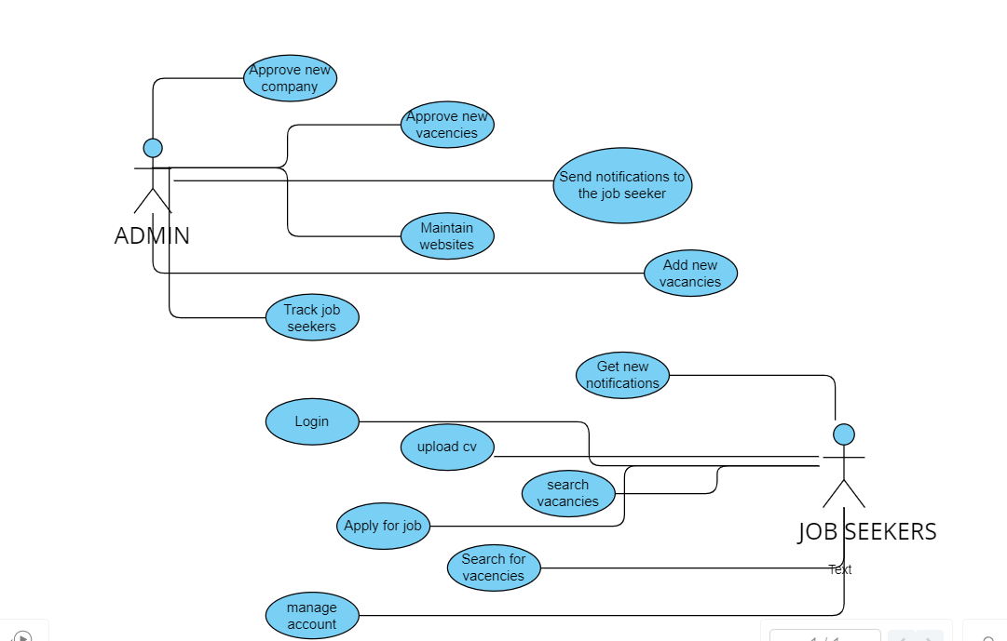

This is a broad level diagram of the project showing a basic overview. The users can be either job seeker or employers. This System will provide a search functionality to facilitate the search of resources. This search will be based on various categories viz. job name or the vacancies. Further the admin personnel can add/update the details of company.

PRODUCT FUNCTION :

Entity Relationship Diagram of Library Management System

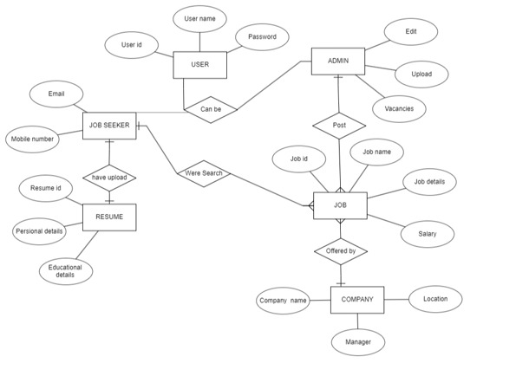

The job portal System provides online real time information about the job vacancy available in the company and the information. The main purpose of this project is to reduce the manual work. This software is capable of managing time and Generating various Reports for Record-Keeping according requirements. The admin will act as control members and manage job vacancies. The valid members are also allowed to view their account information.

1. User Classes and Characteristics

The system provides different types of services based on the type of users [job seeker/admin]. The admin will be acting as the controller and he will have all the privileges of an administrator. The member can be job seeker who will be accessing the job portal online.

The features that are available to the (job seeker) user are:

1.Users can create personalized profiles containing their resumes, work experience, education skills, and other relevant information.

2.Users can search for jobs based on various criteria such as job title, location, industry, salary range, and company.

3.Users can upload their resumes to the portal, making it easier to apply for jobs directly or be discovered by recruiters.

4.The portal may provide job recommendations based on the user's profile, preferences, and past job searches.

5.Users can track the status of their job applications, view submitted applications, and manage their job search activity.

6.Users can save job postings for future reference or apply later.

7.Users can set up alerts to receive notifications about new job postings matching their preferences.

8. Some portals offer communication channels such as messaging or email to interact with employers or recruiters.

9.Users can access information about different companies, including company profiles, reviews, and ratings.

10.Some portals offer resources like interview tips, sample questions, and advice to help users prepare for interviews.

The feature available in the admin are:

1. Ability to manage user accounts, including creating, modifying, or deleting user profiles, as well as handling user roles and permissions.

2. Oversight of job postings, including approval, editing, removal, or flagging inappropriate listings.

3.Access to data analytics and reporting tools to track user activity, job application trends, website traffic, and other relevant metrics.

4. Control over website content, such as editing static pages, managing FAQs, updating guidelines, and maintaining a blog or news section.

5.Managing and maintaining the database that stores user information, job postings, resumes, and other relevant data securely.

6.Implementing and managing security measures to protect user data and prevent cybersecurity threats. This includes managing access controls, encryption, and compliance with data privacy regulations.

7. Handling user queries, providing customer support, and resolving technical issues or disputes.

8. If the platform offers premium services or subscriptions, the admin may manage payment processing, subscription plans, and billing-related activities.

9. Managing automated email notifications, system alerts, and communication channels to engage with users, such as newsletters or updates.

10. Implementing updates, new features, and improvements to the platform's functionality, ensuring a user-friendly experience.

1. Operating Environment

The product will be operating in windows environment. The job portal System is a website and shall operate in all famous browsers, for a model we are taking Microsoft Internet Explorer, Google Chrome and Mozilla Firefox . Also it will be compatible with the IE 6.0. Most of the features will be compatible with the Mozilla Firefox & Opera 7.0 or higher version. The only requirement to use this online product would be the internet connection.

The hardware configuration include Hard Disk: 40 GB, Monitor: 15” Color monitor, Keyboard: 122 keys. The basic input devices required are keyboard, mouse and output devices are monitor, printer etc.

1. Assumptions and Dependencies

The assumptions are:

The coding should be error free

The system should be user-friendly so that it is easy to use for the users

The information of all users, job seeker and admin must be stored in a database that is accessible by the website

The system should have more storage capacity and provide fast access to the database

The system should provide search facility and support quick transactions

The job portal system is running 24 hours a day

Users may access from any computer that has Internet browsing capabilities and an Internet connection

Users must have their correct usernames and passwords to enter into their online accounts and do actions

The dependencies are:

The specific hardware and software due to which the product will be run

On the basis of listing requirements and specification the project will be developed and run

The end users (admin) should have proper understanding of the product

The system should have the general report stored

The information of all the users must be stored in a database that is accessible by the Library System

Any update regarding the book from the library is to be recorded to the database and the data entered should be correct.

1. Requirement

Software Configuration:

This software package is developed using java as front end which is supported by sun micro system. Microsoft SQL Server as the back end to store the database.

Operating System: Windows NT, windows 98, Windows XP Language: Java Runtime Environment, Net beans 7.0.1

(front end) Database: MS SQL Server (back end)

Hardware Configuration: Processor: Pentium(R)Dual-core CPU Hard Disk: 40GB RAM: 256 MB or more

1. Data Requirement

The inputs consist of the query to the database and the output consists of the solutions for the query. The output also includes the user receiving the details of their accounts. In this project the inputs will be the queries as fired by the users like create an account, selecting jobs and apply into the site. Now the output will be visible when the user requests the server to get details of their account in the form of time.

## 3. External Interface Requirement

1. GUI

The software provides good graphical interface for the user and the administrator can operate on the system, performing the required task such as create, update, viewing the details of the job.

It allows user to view quick reports like job details in particular time.

It provides job verification and search facility based on different criteria.

The user interface must be customizable by the administrator

All the modules provided with the software must fit into this graphical user interface and accomplish to the standard defined

The design should be simple and all the different interfaces should follow a standard template

The user interface should be able to interact with the user management module and a part of the interface must be dedicated to the login/logout module

Login Interface:

In case the user is not yet registered, he can enter the details and register to create his account. Once his account is created he can ‘Login’ which asks the user to type his username and password. If the user entered either his username or password incorrectly then an error message appears.

Search:

The job seeker or admin can enter the type of job he is looking for and he is interested. he can search for the required job by entering the job name.

Categories View:

Categories view shows the categories of jobs available and provides ability to the admin to add/edit or delete category from the list.

Admin’s Control Panel:

This control panel will allow Admin to add/remove users; add, edit, or remove a resource. And manage lending options.

## 4. System Features

The users of the system should be provided the surety that their account is secure. This is possible by providing:

User authentication and validation of members using their unique member ID

Proper monitoring by the administrator which includes updating account status.

Proper accountability which includes not allowing a member to see other member’s account. Only administrator will see and manage all member accounts

## 5. Other Non-functional Requirements

1. Performance Requirement

The proposed system that we are going to develop will be used as the Chief performance system within the different campuses of the university which interacts with the job admin and job seeker. Therefore, it is expected that the database would perform functionally all the requirements that are specified by the job portal.

The performance of the system should be fast and accurate

Job portal System shall handle expected and non-expected errors in ways that prevent loss in information and long downtime period. Thus it should have inbuilt error testing to identify invalid username/password

The system should be able to handle large amount of data. Thus it should accommodate high number of jobs and users without any fault

1. Safety Requirement

The database may get crashed at any certain time due to virus or operating system failure. Therefore, it is required to take the database backup so that the database is not lost. Proper UPS/inverter facility should be there in case of power supply failure.

1. Security Requirement

System will use secured database

Normal users can just read information but they cannot edit or modify anything except their personal and some other information.

System will have different types of users and every user has access constraints

Proper user authentication should be provided

No one should be able to hack users’ password

There should be separate accounts for admin and members such that no member can access the database and only admin has the rights to update the database.

1. Requirement attributes

There may be multiple admins creating the project, all of them will have the right to create changes to the system. But the members or other users cannot do changes

The project should be open source

The Quality of the database is maintained in such a way so that it can be very user friendly to all the users of the database

The user be able to easily download and install the system

1. Business Rules

A business rule is anything that captures and implements business policies and practices. A rule can enforce business policy, make a decision, or infer new data from existing data.This includes the rules and regulations that the System users should abide by. This includes the cost of the project and the discount offers provided. The users should avoid illegal rules and protocols. Neither admin nor member should cross the rules and regulations.

1. User Requirement

The users of the system are job seeker and admin who act as administrator to maintain the system. The members are assumed to have basic knowledge of the computers and internet browsing. The administrators of the system should have more knowledge of the internals of the system and is able to rectify the small problems that may arise due to disk crashes, power failures and other catastrophes to maintain the system. The proper user interface, user manual, online help and the guide to install and maintain the system must be sufficient to educate the users on how to use the system without any problems.

The admin provides certain facilities to the users in the form of:

Backup and Recovery Forgot Password Data migration i.e. whenever user registers for the first time then the data is stored in the server

Data replication i.e. if the data is lost in one branch, it is still stored with the server

Auto Recovery i.e. frequently auto saving the information

Maintaining files i.e. File Organization

The server must be maintained regularly and it has to be updated from time to time

## 6. Other Requirements

1. Data and Category Requirement

There are different categories of users namely admin, job seeker etc. Depending upon the category of user the access rights are decided. It means if the user is an administrator then he can be able to modify the data, delete, append etc. All other users except the admin only have the rights to retrieve the information about database. Similarly there will be different categories of jobs available. According to the categories of jobs their relevant data should be displayed. The categories and the data related to each category should be coded in the particular format.

1. Appendix

A: Admin, Abbreviation, Acronym, Assumptions; B: Business rules; C: Class, Client, Conventions; D: Data requirement, Dependencies; G: GUI; K: Key; J: jobs; M: Member; N: Non-functional Requirement; O:

Operating environment; P: Performance, Perspective, Purpose; R: Requirement, Requirement attributes; S: Safety, Scope, Security, System features; U: User, User class and characteristics, User requirement;

1. Glossary

The following are the list of conventions and acronyms used in this document and the project as well:

Administrator: A login id representing a user with user administration privileges to the software User: A general login id assigned to most users

Client: Intended users for the software

SQL: Structured Query Language; used to retrieve information from a database

SQL Server: A server used to store data in an organized format

Layer: Represents a section of the project

User Interface Layer: The section of the assignment referring to what the user interacts with directly

Application Logic Layer: The section of the assignment referring to the Web Server. This is where all computations are completed

Data Storage Layer: The section of the assignment referring to where all data is recorded

Use Case: A broad level diagram of the project showing a basic overview

Class diagram: It is a type of static structure diagram that describes the structure of a system by showing the system’s cases, their attributes, and the relationships between the classes

Interface: Something used to communicate across different mediums Unique Key: Used to differentiate entries in a database

1. Class Diagram

A class is an abstract, user-defined description of a type of data. It identifies the attributes of the data and the operations that can be performed on instances (i.e. objects) of the data. A class of data has a name, a set of attributes that describes its characteristics, and a set of operations that can be performed on the objects of that class. The classes’ structure and their relationships to each other frozen in time represent the static model. In this project there are certain main classes which are related to other classes required for their working. There are different kinds of relationships between the classes as shown in the diagram like normal association, aggregation, and generalization. The relationships are depicted using a role name and multiplicities. Here ‘user’, ‘job seeker’ and ‘admin’ are the most important classes which are related to other classes.

